Ex. No. 1 | JAVA LOOPS
YouTube Link
Date of Exercise | DD.MM.YYYY

Aim
To understand and demonstrate the functionality and usage of different types of loops (for, while, do-while) in Java programming.

Description
Loops in Java are control flow statements that allow a block of code to be executed repeatedly based on a given boolean condition. They are essential for tasks requiring iteration over data structures, performing repetitive calculations, or processing input until a specific condition is met. The three primary loop types are: 1. **for loop**: Used when the number of iterations is known beforehand. It provides a concise way to initialize, test, and increment/decrement a counter variable. 2. **while loop**: Used when the number of iterations is not known in advance, and the loop continues as long as a condition remains true. The condition is evaluated before each iteration. 3. **do-while loop**: Similar to the while loop, but it guarantees that the loop body will execute at least once, as the condition is evaluated after the first iteration.

Program
public class JavaLoopsDemo {
public static void main(String[] args) {
System.out.println("Demonstrating Java Loops:\n");
// 1. For Loop
System.out.println("--- For Loop (counting from 1 to 5) ---");
for (int i = 1; i <= 5; i++) {
System.out.println("Count (for): " + i);
}
System.out.println("For loop finished.\n");
// 2. While Loop
System.out.println("--- While Loop (counting from 1 to 3) ---");
int j = 1;
while (j <= 3) {
System.out.println("Count (while): " + j);
j++;
}
System.out.println("While loop finished.\n");
// 3. Do-While Loop
System.out.println("--- Do-While Loop (counting from 1 to 2) ---");
int k = 1;
do {
System.out.println("Count (do-while): " + k);
k++;
} while (k <= 2);
System.out.println("Do-While loop finished.\n");
// Example of do-while executing at least once (condition false initially)
System.out.println("--- Do-While Loop (executes once even if condition is false) ---");
int m = 5;
do {
System.out.println("This will print once (m = " + m + ")");
m++;
} while (m < 5);
System.out.println("Do-While loop (false condition) finished.\n");
}
}

Output Screenshot
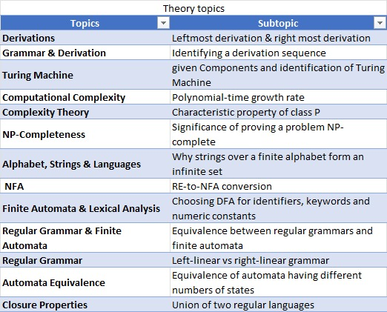

Result
The program successfully demonstrated the behavior of `for`, `while`, and `do-while` loops in Java by printing sequential outputs. Each loop type iterated as expected, confirming their distinct control flow mechanisms. The objective of understanding and demonstrating Java loop functionality was successfully achieved.

